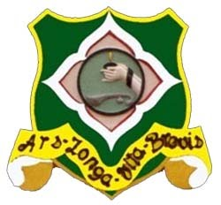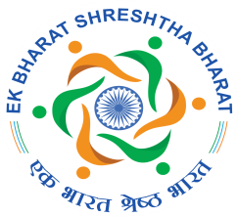

AVVAIYAR GOVERNMENT COLLEGE FOR WOMEN, KARAIKAL
PUDUCHERRY -609602

REPORT OF EK BHARAT SHRESHTHA BHARAT
CLUB INAUGURATION
29th November 2019

Head of the Institution: Dr. W.V. Balaji

Ms. Teresa Tudu
Nodal Officer, AGCW

The Ek Bharat Shreshtha Bharat Scheme was initiated in the U.T. of Puducherry as per the instruction of the NITI Aayog by means of signing a MoU with the U.T. of Daman and Diu on the 31st October 2016, in the presence of the Honourable Prime Minister. The proposal was to conduct various cultural events, film festival, exchange programmes, competitions etc.
INAUGURATION OF EBSB CLUB
As per the direction of MHRD, GOI, to have Nodal Officer for the institution Ms. Teresa Tudu, Assistant Professor, Dept. of English, was appointed as the Nodal Officer for the Avvaiyar college.
On 29th November 2019, around 3.00 PM in the afternoon Ek Bharat Shreshtha Bharat club was inaugurated in the Conference hall of the college. Around 30 faculty members of the college attended the inaugural function. The programme started with inaugural speech by the Principal Dr. W. V. Balaji. He discussed in brief about the aims and benefits of this nationwide Ek Bharat Shreshtha Bharat Scheme and talked about the need of the EBSB club in the college for its successful implementation. He also appreciated the Government for this initiation which aims to create mutual understanding and bonding between the people of different states and culture.
The programme was further taken over by Ms. Teresa Tudu, Nodal Officer (EBSB). She discussed in detail about the Ek Bharat Shreshtha Bharat scheme with the help of a Power Point presentation. Starting with the launch of the EBSB programme on Ekta Diwas (31 Oct. 2016), she highlighted many important points related to it. She familiarized the audience with its objectives and other programmes under EBSB, designed to fulfil those objectives. After the presentation and talk centered on the EBSB programme, she focused on the upcoming event of EBSB Puducherry, i.e. Student Exchange Programme. She briefed about the action plan of this event and requested faculty members to select deserving students for the visit to the paired state Daman & Diu. Towards the end of the talk Ms. Teresa announced the formation of EBSB club in the college and briefed everyone regarding the aims and objectives of this club along with its activities. She concluded her presentation with a note of encouragement to all the students and staff to become the member of this club.
The inaugural function ended with the valedictory speech by the Principal, Dr. W.V. Balaji who congratulated Staff members for the inauguration of EBSB club and thanked everyone for their gracious presence on the occasion.

PHOTOS

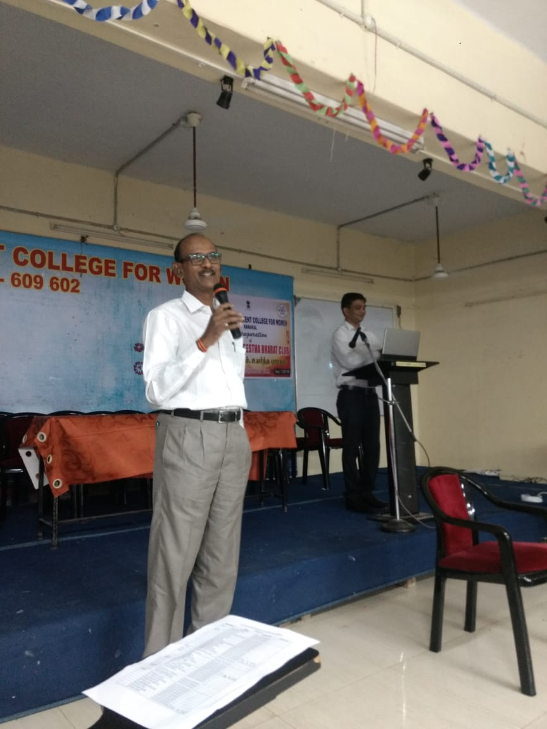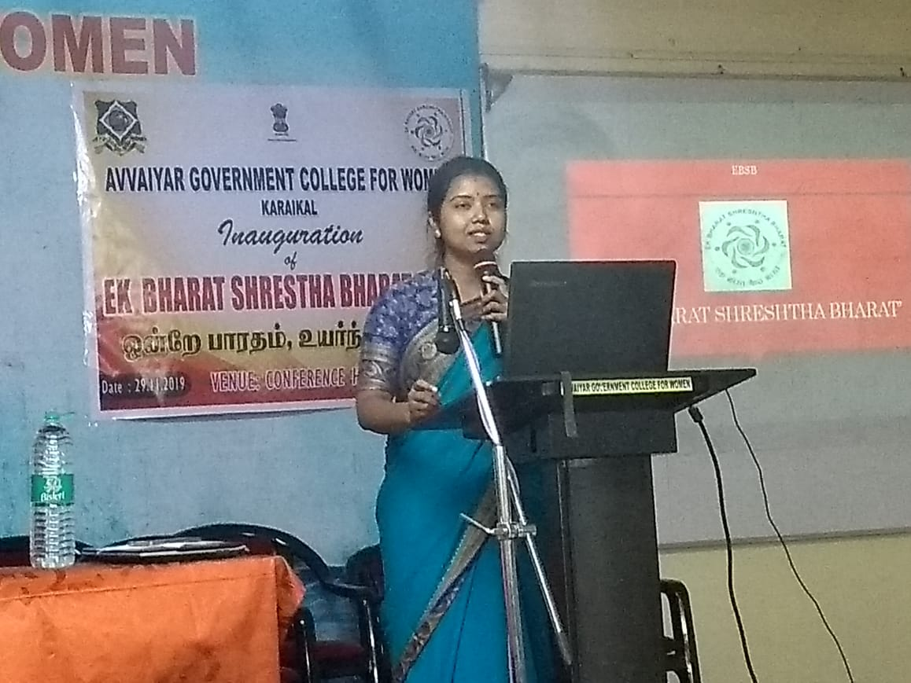

Special Address by the Principal Dr. W.V. Balaji Power point presentation on EBSB by Ms. Teresa Tudu, Nodal Officer (EBSB)

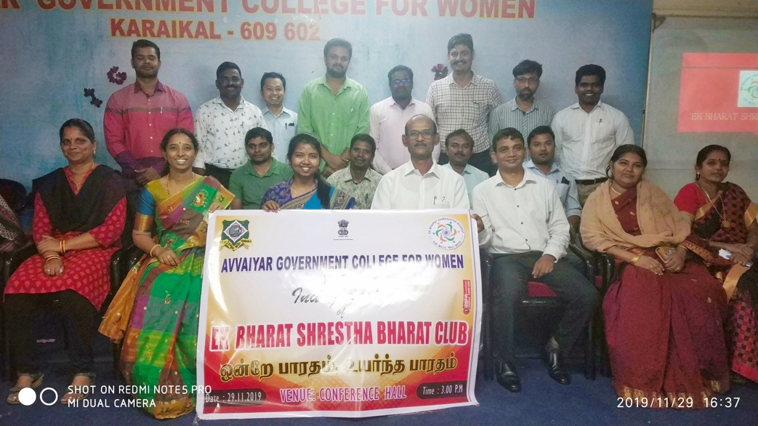
Dr. W.V. Balaji with club members EBSB

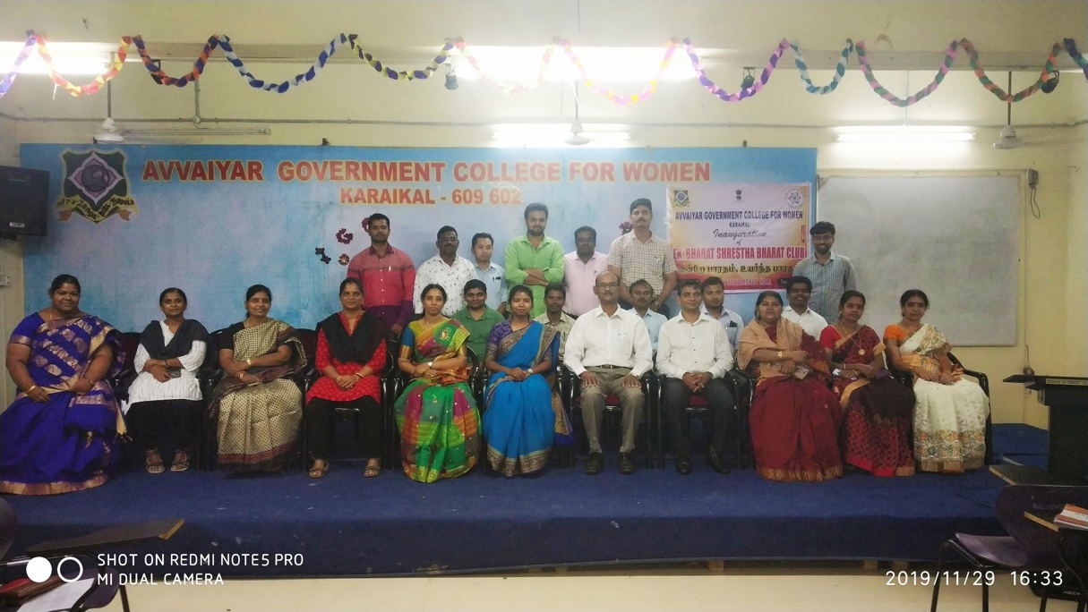
Post-inauguration group photo

----------------------------------

